Materi : PBO – Praktikum 1
NIM : A11.2016.09493
Nama : Rizki Mufti Ilmawan
Kelompok : A11.4110

1. TUGAS 1 : Menampilkan Biodata Lengkap

public class MyBiodata{
public static void main (String[] args) {

String nama = "Rizki Mufti Ilmawan";
String nim = "A11.2016.09493";
String kelompok = "A11.4410";
String ttl = "Subang 20 Mei 1998";
String alamat = "Semarang";
String email = "rizkimufti@gmail.com";
String hp = "082217808429";
String ig = "@rzlnx";

System.out.println("Nama : "+nama);
System.out.println("NIM : "+nim);
System.out.println("Kelompok : "+kelompok);
System.out.println("TTL : "+ttl);
System.out.println("Alamat : "+alamat);
System.out.println("Email : "+email);
System.out.println("No.Telepon : "+hp);
System.out.println("Instagram : "+ig);

}

}
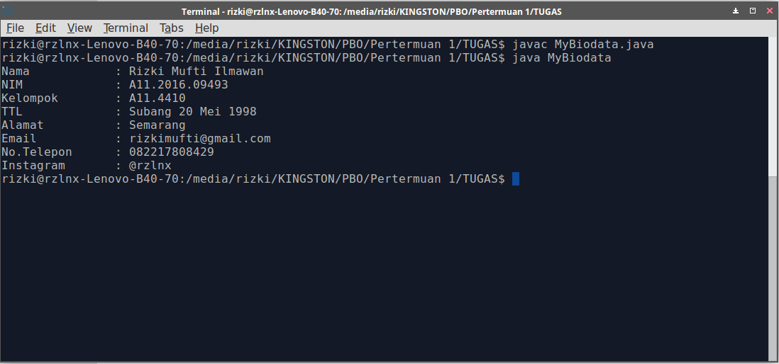

TUGAS 2 :

Segitiga :

public class segitiga {
public static void main(String[] args) {
int alas= 6 ;
int tinggi = 5;
int sisiA=6;
int sisiB=7;
int sisiC=8;

double luassegitiga=0.5 * alas * tinggi ; //rumus luas segitiga 1/2 * alas * tinggi
double kelsegitiga=sisiA + sisiB + sisiC; // rumus kel segitga sisiA + sisiB + sisiC

System.out.println ("Luas Segitiga = "+luassegitiga);
System.out.println("Kelliling Segitiga = "+kelsegitiga);
}
}

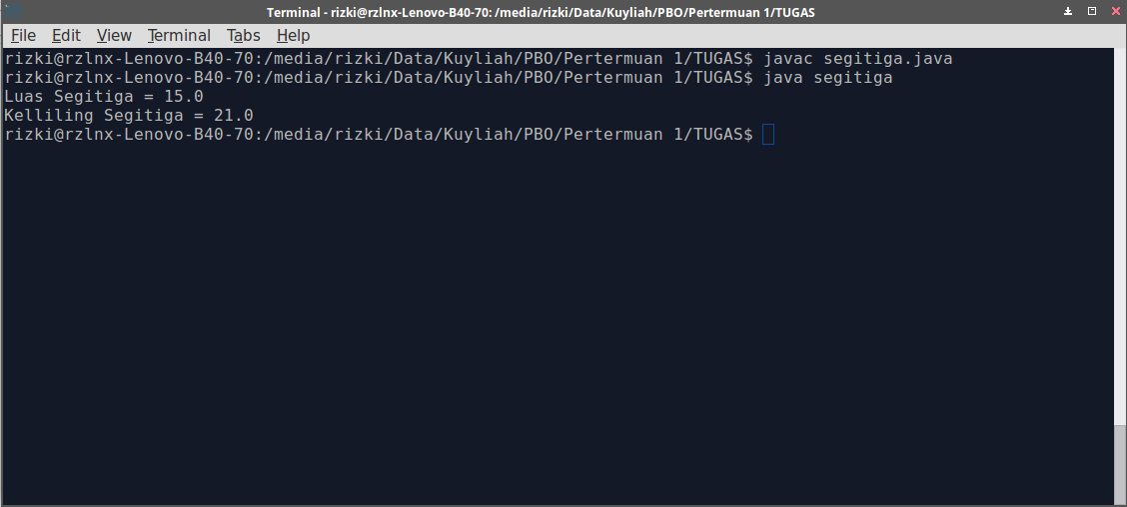

Lingkaran :

public class lingkaran {
public static void main (String [] args){
double phi = 3.14;
int r = 7;
double luas = phi * r * r; //rumus luas lingkaran
double keliling = 2* phi * r //rumus keliling lingkaran

System.out.println("luas lingkaran = " +luas);
System.out.println("keliling lingkaran = " +keliling);
}
}

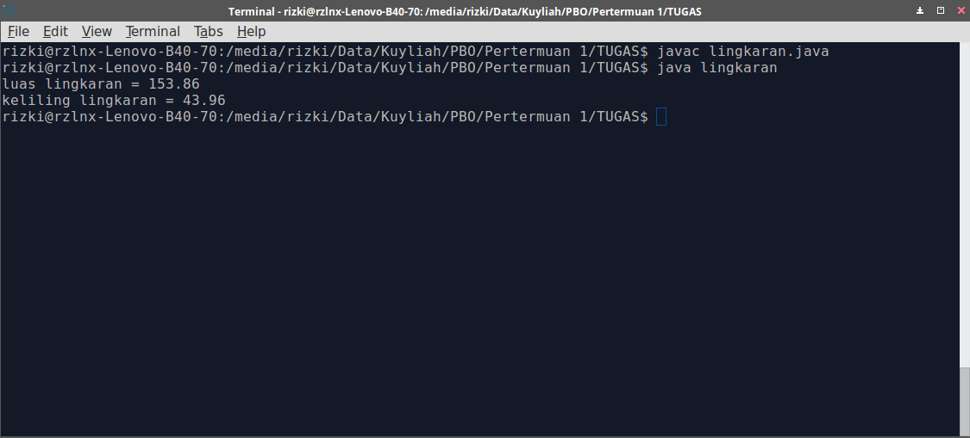

Kubus

public class kubus {
public static void main(String[] args) {
int s=4;
double luaskubus= (s*s)*6; //rumus L = 6 x s²
double kelkubus = s*12; // rumus K = 12 x s

System.out.println ("Luas Kubus = "+luaskubus);
System.out.println("Kelliling Kubus = "+kelkubus);

}
}

